Problem 1
- a 32 bits b 32 bits c 32 bits

Explain: Since our computer is 4GB byte-addressable, the length of each address is 32bits. Since a,b,c are all memories, and there is only one instruction in Turing complete, we don’t need any opcode to encode one instruction, we can conclude that the total length of one instruction is 3*32+0 = 96bits.

- 3 address ISA. Memory-memory ISA.

- L0: subleq C, C, L1 # C=C-C=0<=0 go to L1, C=0
L1: subleq D, D, L2 # D=D-D=0<=0 go to L2, D=0
L2: subleq A, B, L6 # A=A-B=16>0 go to L3, A=16
L3: subleq D, B, L4 # D=D-B=9>0 go to L4, D=9
L4: subleq C, D, L5 # C=C-D=-9<=0, go to L5, C=-9
L5: subleq D, D, L9 # D=D-D=0<=0, go to L9, D=0
L6: subleq D, A, L7 # not executed
L7: subleq C, D, L8 # not executed
L8: subleq D, D, L9 # not executed
L9: //Rest of code # end

Finally, A = 16, B = -9, C = -9, D = 0; this snippet tries to compare the value stored in A and B, if A>B, it will store the smaller value into C and clear the value in D, and it will store the difference between A and B into A. If A<=B, it will store the difference of A-B into A and C, also the value stored in D will be cleared. In two cases, the value stored in B remains constant.
- L1: Subleq M2, M2, L2 # clear M2 to 0
L2: Subleq M2, M0, L3 # M2 = M2 – M0 = -N
L3: Subleq M1, M2, L4 # M1 = M1 – M2 = N, we assume M1 equals to 0 initially
L4: Subleq M0, C1, Lend # M0 = M0 – C1 = N -1
L5: Subleq M2, M2, L2 # clear M2 to 0 and jump back to L2
Lend:

Problem 2
- Sub rx, rx, rx # clear rx
Sub rx, rt, rx # rx = rx – rt = - rt
Sub rs, rx, rd # rd = rs – rx = rs + rt
- Or rs, rt, rd #rd = rs | rs
Xor rs, rt, rt # get xor result into rt
Sub rd, rt, rd # get and result by substracting rd with rt
Xor rs, rt, rt # recover rt
- Lhu rs, rt, imm+2 # get the last two bytes, 0 extension
Sub rx, rx, rx # clear rx to 0
Lhu rs, rx, imm # get the first two bytes
Sll rt, rt, 16 # left shift rt
Add rx, rt, rt # add two register
- Add $0, rx, jumpAddress
Jr rx
this one is not necessarily correct, because jumpAddress does not include the 4 MSB of PC. We also try beq rx,rx,jumpAddress, but this also does not work, since PC = PC + jumpAddress, which is not the same with jumpAddress. We cannot think of other correct choices so we just use this as our answer…

Problem 3
- 3-address
Thumb : ADD Rd, Rs, Rn ARM : ADDS Rd, Rs, Rn
2-address
Thumb : CMP Rd, Rs ARM : CMP Rd, Rs

- Displaced:
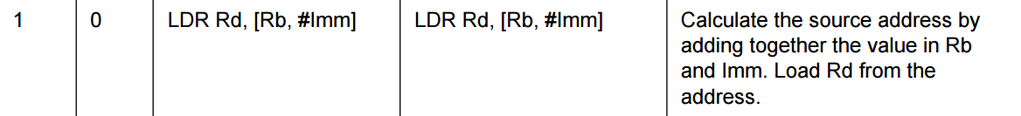
Indexd :
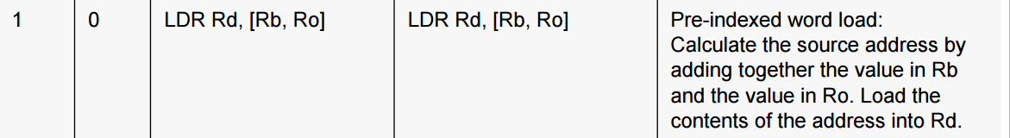
Absolute: this can be considered as one absolute, since Rd -> (PC+#imm)
